**6491-2017 P3: Runner**

# Deliverables

No write-up. Just the sketch and all its files and a video of a minute showing your results.

The video should have proper title, and section titles or running subtitles explaining what we are seeing.

The video title should be:

CS6491-2017 Project 3: Runner

Authors names

This is a team project, but you can do it alone. A more substantial result is expected from teams than from individuals.

You have the choice of two different topics, plus some options for extra credit (which may help if you run out of steam for one of the projects or don’t do so well on the midterm), including the super option of combining both.

# Given base code

You are given 2 base code sketches that you can use to get started. These are posted in the P3 folder on dropbox.

1. “3D curve editor” lets the user edit a curve on a the floor and show it as a 3D tube. It also shows a green version of that curve and an inverted red arrow between the corresponding points on both curves. This is the starting point for your project.

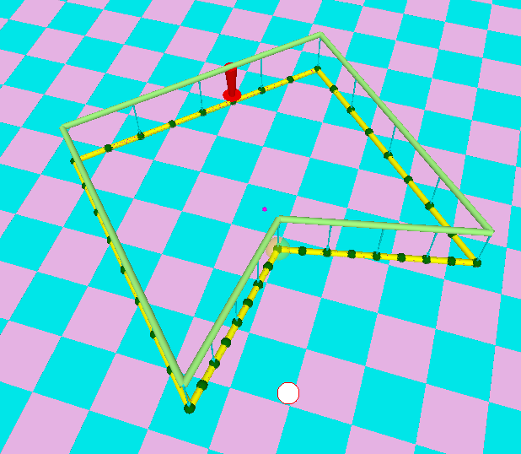

1. 3D base let’s you pick and drag a dancer’s feed and displays the dancer’s lower body.

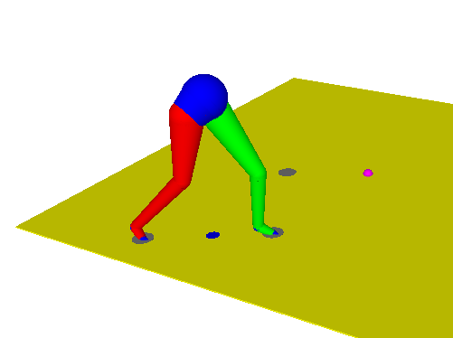

You are welcome to use either of them or to combine them.

# Option 1: Runner

Replace the yellow and green curves by the result of a quintic B-spline subdivision.

Then display the bottom of the red arrow outwards of the turns, by the proper amount (so that gravity compensates for the centripetal force). The top of the red arrow (head of the runner) should follow the subdivided green curve. The bottom of the arrow (feet of the runner) should slide on the floor but follow an offset curve that is displaced from the subdivided (yellow) curve.

Options:

1-Use retrofitting to make the subdivided curves nearly interpolating

2-Replace the red arrow by the half-body of the runner and have the (red / green) feet alternate (one is stationary, and the other one makes a step along the offset curve).

3-Add an upper body made of caplets.

# Option 2: Fleshing our strokes

Turn your strokes from project 2 (or from project 1) into tubes (solids in 3D of a circular cross-section).

Use the control points of the “3D curve editor” to control the 2D version of the stroke on the floor.

Show the 3D bulging above and below the floor as a quad-mesh surface.

# Option 3: Combination

Replace the 3 sections of the legs of the dancer by designed 3D strokes that better approximate human anatomy.

Options:

* Use these 3D strokes to build the upper body and head.
* Have the 3D strokes deform a little to animate muscle bulging during the running step